Step 1) On the home page of the portal click on “Service Request”.
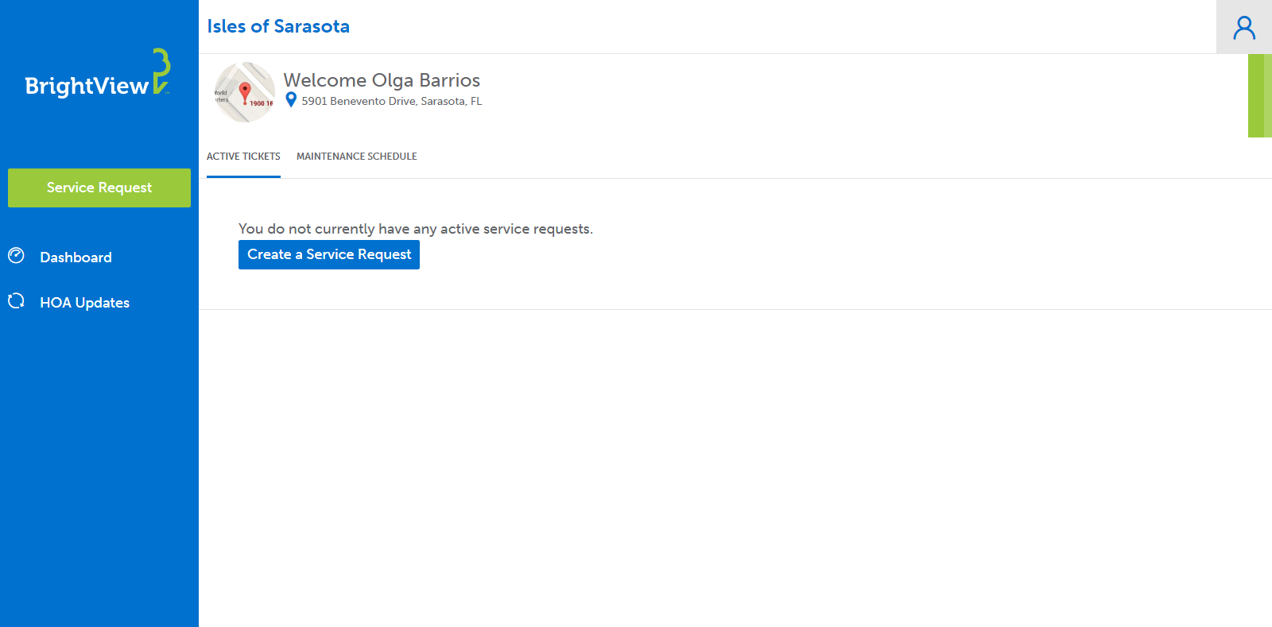
Step 2) Select a category to create a service request. You have 10 categories to choose from. Refer to “Which Category Should I Choose On The Portal?” for more details. Form is located at the end of this instruction guide.
PLEASE NOTE: Each landscaping request requires its own individual service request.
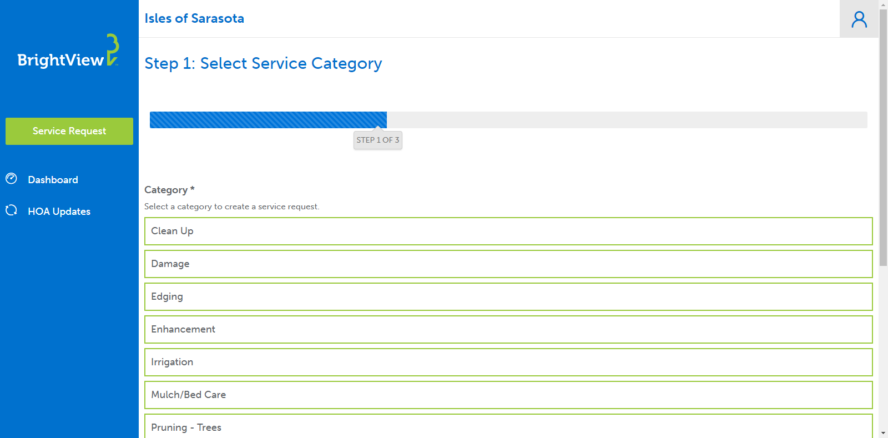

Step 3) Fill in the blanks and click “Next”. In the description box, please identify the location of your request. It’s extremely helpful to include pictures.

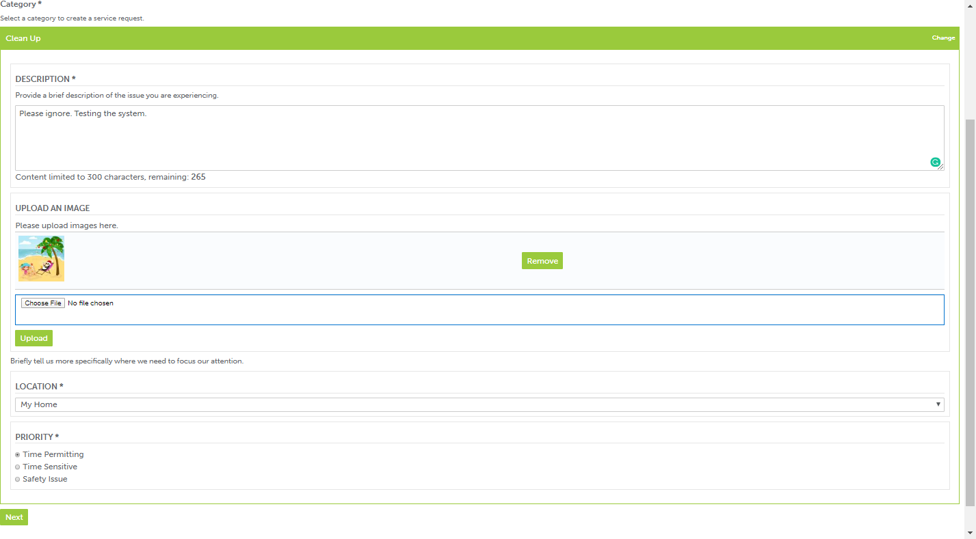
Click “Choose File” to select your picture. Then, click “Upload” to save it on the service request.
Multiple pictures can be uploaded, but they must be done one at a time.

Step 4) Click “Review Your Request” if this is the only request you are submitting.

If you have multiple requests to submit, click on “Add new Service Request” and follow the same instruction starting from step #1. This way, you can submit multiple requests at once.
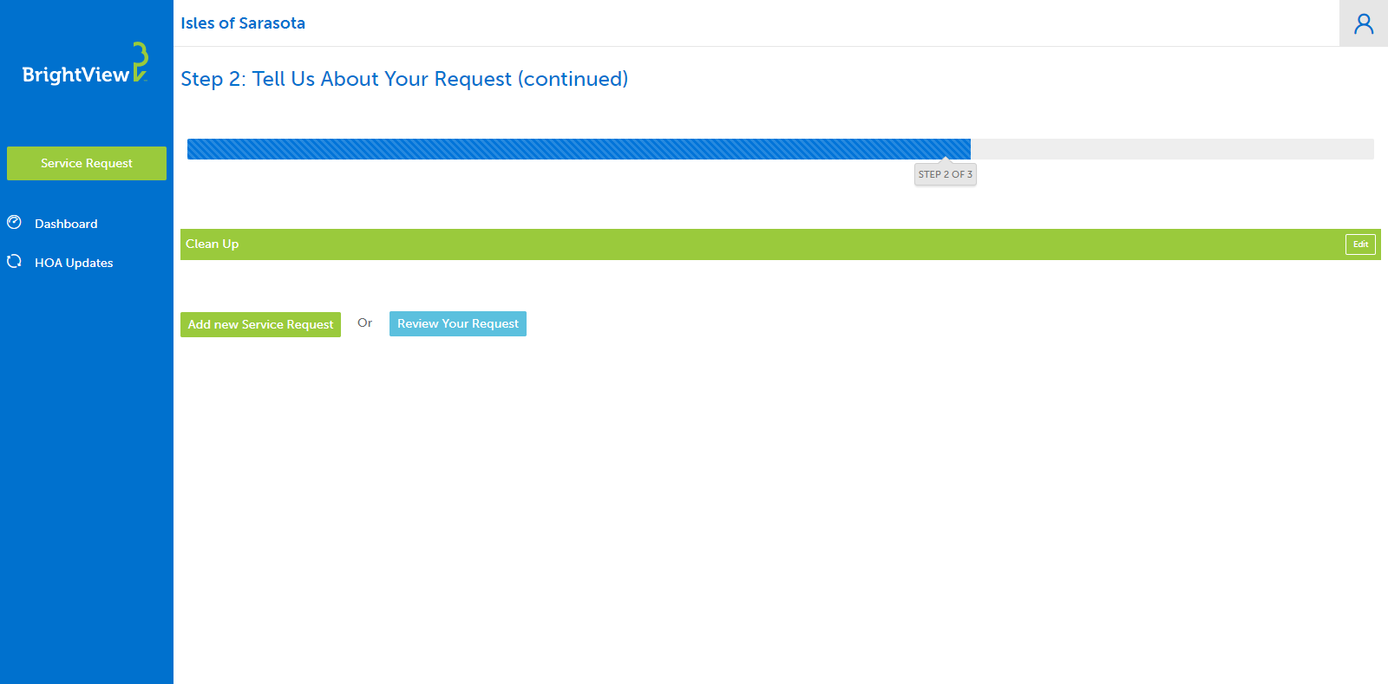

Step 5) Click “Submit Your Request” to finalize the request. You are all done!

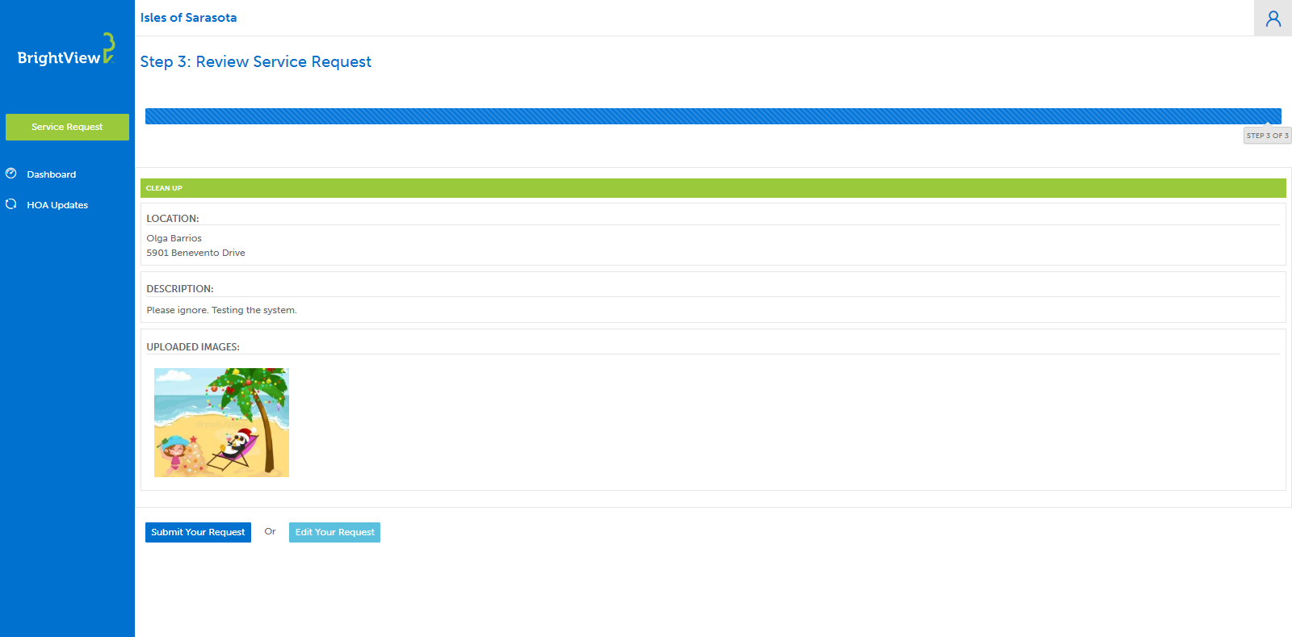

WHICH CATEGORY SHOULD I
CHOOSE ON THE PORTAL?

Here’s a breakdown of the type of requests you should submit under each category. Along the way, we are going to answer frequently asked questions.
Bullet points - identifies work which is generally included with the landscaping contract at no extra cost to homeowner or association.
Note - additional information you may need to know such as additional cost to the association or homeowner.
Follow-Up Request – If you are wishing to get a status update on your submitted service request; you can do so by opening your service request ticket and write a comment requesting a status update.
A separate request must be submitted for each category request. For example, if you have a trimming request and irrigation request two separate request must be submitted.
We ask that you please DO NOT submit a second request for the same service. This will create confusion causing a service delay.
CLEAN UP - Landscaping debris such as:
- Fallen Tree Limb
- Palm boots
- Any fallen landscaping
NOTE: This DOES NOT include any landscaping debris in a designated wetland or preserved area. See Wetland/Preserved map to familiarize yourself with those areas.
Click to view map: Isles of Sarasota Wetland/Preserved Area Map (you can also find this on the Isles website under the “News” tab.)
DAMAGE - Any damages to personal property caused by a BrightView staff such as:
- House
- Gutter
- Lanai screen
- Palm limbs can be placed curbside for BrightView to pick up on Thursdays.
NOTE: Must include picture(s) along with request. During palm trimming season, please remove all outdoor decors including landscape lighting. BrightView will not be held responsible for replacing broken décor.

EDGING - Includes the following:

Edging – Includes the following:

Edging – Includes the following:

- Garden Bed
- Driveway
- Sidewalks
Plant or Grass replacement.
Enhancement - Dead plant(s) or grass that needs to be replaced.

Edging – Includes the following:

Edging – Includes the following:

- The association ONLY replaces dead plant(s) and grass based on the advice of BrightView.

- If plant(s) and/or grass are still green, the association will NOT replace.
- All replacements are done monthly; please allow 45 days from the time you submit a request.
- When your request has been reviewed by BrightView and added to the replacement plant list, the portal service request will get closed.
NOTE: Homeowners wishing to replace landscaping at their own expense must submit a request through the portal and in writing through an Architectural Change Committee (ACC) Form, which may be found on the Isles website under “Forms”.

IRRIGATION - Includes the following, but not limited to:

Includes the following, but not limited to:

Includes the following, but not limited to:

Edging – Includes the following:

Edging – Includes the following:

- Broken sprinkler heads
- Leaks
- Dry spots in the grass
- System not running
- Wet Areas

MULCH/BED CARE

Edging – Includes the following:

Edging – Includes the following:

- Mulch is installed annually in October/November and when a new plants are installed.
NOTE: If additional mulch is wanted, homeowners may install mulch at their expense so long as it is Cypress Gold Mulch. This kind of mulch can be found at Big Earth Landscape Supply.
PRUNING – TREES

Edging – Includes the following:

Edging – Includes the following:

- Palms touching a the house or lanai screen.
- When a tree was missed during the trimming rotation.
TRIMMING SCHEDULE:
- Hard cut backs are done during the first quarter of the year on the following plants:
- Jatrophas
- Hibiscus trees (NOT Weeping Hisbiscus bush)
- Crape Myrtles

- Palm trees UNDER 15ft are trimmed as part of the regular trimming rotation when required based upon best pruning practice.
NOTE: Palm trees OVER 15ft are trimmed twice a year: Spring & Fall by a different BrightView crew. All other trees are pruned upon request and at the discretion of management.
PRUNING – SHRUBS

Edging – Includes the following:

Edging – Includes the following:

- When a shrub was missed during trimming rotation.
PRUNING SCHEDULE:
- Pruning is done on a 6 weeks cycle based upon best pruning practices. Not all plants are pruned every 6 weeks.
NOTE: Additional requests for pruning will be reviewed on a case by case basis by the management team.
TURF

Edging – Includes the following:

Edging – Includes the following:

- When your yard was missed during a normal mowing cycle.
- Ants and Grasshoppers treatment – can ONLY be done when grasshoppers are juveniles.
MOWING SCHEDULE:
- April thru September the grass is mowed weekly (weather permitting).
- January thru March, October thru December grass is mowed every other week.
NOTE: Mowing scheduled can be found on the BrightView Portal under “HOA Updates” and bulletin board outside the Post Office. The turf is fertilized four times a year.

WEED CONTROL - Removal/treatment of weeds located in:

Edging – Includes the following:

Edging – Includes the following:

- Driveways
- Paver sidewalks
- Plant beds
- Turf
NOTE: Weed management is completed through liquid treatment and at times hand pulling.

